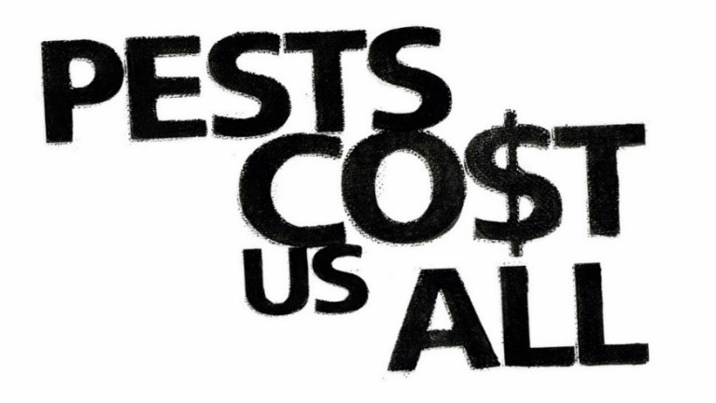



**BUILDING LANDHOLDER MANAGEMENT FOR WEEDS**

**Help stop new pests and control the ones we have. Pest control is everyone’s business.**

This **free workshop** will focus on **BUILDING LANDHOLDER MANAGEMENT FOR WEEDS**

Facilitated by our local Northern and Yorke NRM staff, this half day session will provide an overview of weed management principles and the knowledge required to plan and implement effective weed management.

**Chris Brodie, SA Herbarium will cover:**

* Weedy and emerging ‘ALERT’ grasses
* Buffel and needle grass
* How to get weeds identified for management purposes, bring a weed for a quick ID!
* Practical ‘pressing and recording’ plants session

**Hamish Dickson, Agri Partner Consulting Principal Livestock Consultant will cover:**

* Weeds in pasture identification
* Consideration of active growth period and matching livestock needs
* Nutritional value of grazing weeds and grasses
* What are the alternatives?

**Wednesday 21 June 2017 · 9am to 1pm**

Paskeville Football Club, Paskeville Oval (lunch provided)

For more information and to register, contact Kristin Murdock on   
(08) 8853 3880 / 0400 283 015 or [Kristin.Murdock@sa.gov.au](mailto:Kristin.Murdock@sa.gov.au)

Visit the Pests Cost Us All website for more workshop details, online training modules and fact sheets [**www.pir.sa.gov.au/pestscostusall**](http://www.pir.sa.gov.au/pestscostusall)

*This initiative has been funded through the Australian Government’s Agricultural Competitiveness White Paper, the government’s plan for stronger farmers and a stronger economy.*